Shoreline Change Special Area Management Plan (Beach SAMP)
Stakeholder Meeting

Corless Auditorium
University of Rhode Island, Narragansett Bay Campus
July 14, 2015, 6:00 – 8:00 pm

Agenda

Meeting Purpose: Review progress to date on development of tools, and discuss the next phases of the Beach SAMP project.

6:00 | Welcome – Michelle Carnevale, URI Graduate School of Oceanography Coastal Resources Center & RI Sea Grant
6:05 | Update on Beach SAMP Tools  - STORMTOOLS (Michelle Carnevale, URI GSO CRC/RISG & Grover Fugate, RI CRMC)  - Shoreline Erosion Mapping (Jon Boothroyd, URI & Bryan Oakley, Eastern CT State Univ.)  - SLAMM Update (Jim Boyd, RI CRMC)  - Salt Marsh Restoration Projects (Caitlin Chaffee, RI CRMC)  - Tools for Adaptation: Municipalities, Waterfront Businesses and Coastal Property Owners (Michelle Carnevale, URI GSO CRC/RISG)
7:00 | Where are we with the Beach SAMP? – Grover Fugate, Executive Director, Rhode Island Coastal Resources Management Council
7:15 | Beach SAMP Document (M. Carnevale)  - Overview of Process  - Table of Contents
7:35 | Discussion and Questions
8:00 | Adjourn

This effort has been made possible thanks to the generous support from: the Rhode Island Bays, Rivers, and Watersheds Coordination Team; the URI Coastal Institute; Rhode Island Foundation; and the Rhode Island Sea Grant College Program.

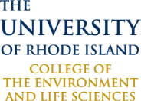
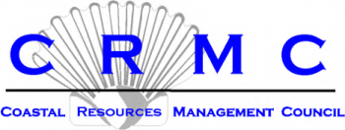
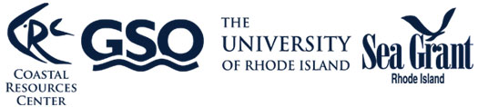
www.beachsamp.org

